Name:
Professor:
Course:
Date:

System error estimate using combination of classification and optimization technique

Author Responses to Editor and Reviewers
Dear Chief Editor,
I take this opportunity to thank you for the reviews and comments about my manuscript. The feedback you provided for my paper “System error estimate using combination of classification and optimization technique,” is essential because it will help develop a well-structured and quality paper. The responses to the reviewers’ comments are discussed below. It is my hope that they are consistent with the standards of the Computer Science Journal. I will be glad to make any further clarifications regarding the manuscript if need be.
Thank You.

Responses to Reviewer #1
- Introduction should be extended in order to talk more about data mining and meta-heuristics for the applied application in this paper.
I appreciate this comment. The introduction of the manuscript has been extended to incorporate the following information.
Data mining and meta-heuristics have found numerous applications today, including system error estimation, weather prediction, conducting business forecasts, occurrence of natural disasters, social, political, and cultural changes, and diagnosis among others. Today, software development has become a highly competitive field. However, the process of software development is complex and exposed to errors, especially during the development process. In this context, data mining and meta-heuristics can be applied in his area to ensure that these errors are alleviated and the quality of systems improved. Through data mining, software developers can turn raw data into useful information, which will help them become more vigilant and reduce errors. Problem independent approaches can be applied in system error estimation through the application of algorithms, which will portray relationships between the presence of errors in software development and the competence of software developers. Data mining and meta-heuristics will be applied in the source code and the architecture of the systems. In this paper an optimized software flaw prophecy system is developed based on Data Mining (DM) techniques namely Association Rule mining, Decision Tree, and Naive Bayes Classification integrated with Particle Swarm Optimization technique.
.
- Research gap and contribution should be highlighted.
The current research contributes to the existing knowledge on identifying the contributions of Particle Swarm Optimization (PSO) in identification of errors during software development. Software project managers have relied on different techniques to identify faults in the process. Identification of these faults has enabled software project managers make optimal use of people, costs, and time to improve quality assurance. Also, these techniques have been used to plan production process improvements. The research will provide newer techniques to software developers and managers, which, in turn will enable them develop quality software systems. This research will add to the current knowledge on how the process of software development can be optimized, ensuring all stages of the production process are in check. Ensuring that the implemented policies and standards are adhered to will improve the quality of developed systems.
Numerous researches have been conducted in the area of system error estimation to identify the relationships between the quality metrics and the potential defective modules. The current research seeks to address the existing gap on the use of novel technologies like Particle Swarm Optimization (PSO) to determine these relationships. The research will explore how Machine Learning Clustering has been developed to avoid the software system's failure. Comparing the existing techniques with PSO will enable the audience design or rather adopt effective approaches to analyze large data volumes, which will help make informed decisions and solve problems experienced during software development.
- Literature review is written in a poor way. I suggest to use following papers in order to discuss applications of meta-heuristic algorithms in optimization problems.
This comment was important and helped improve the literature review. The review in my manuscript addressed different topics, including existing research, software error prediction with data mining and PSO using machine topographies like PSO algorithm, association rule mining with PSO, decision tree with PSO, and Naïve Bayes classification with PSO. Measures of performance are also identified in the review.
In the section of related works, the manuscript explores how different systems have been used to estimate errors in system development, a process that leads to the achievement of quality software development. This section also identifies different techniques that have bee used in NASA to help alleviate the probability of experiencing faults. Also, the section addresses the advantages and disadvantages associated with each technique. The second section of the review discusses Software error prediction with DM and PSO. This section explores how different machine topographies, including Association Law Mining, Decision Tree, and Naïve Bayes Classification. The last section discusses measures of performance. In this section, different measures are used to evaluate the performance of software defect prediction models.
In addition to this review, the sources provided in the comments were consulted to have an excellent understanding of data mining and meta-heuristics in system error estimation. The sources are outlined below.
- https://doi.org/10.1016/j.jclepro.2018.10.010https://link.springer.com/article/10.1007/s00500-017-2940-9https://www.inderscienceonline.com/doi/abs/10.1504/IJVCM.2020.111075
- https://www.tandfonline.com/doi/full/10.1080/17509653.2019.1683479
- https://link.springer.com/article/10.1007/s00607-018-00692-2https://www.tandfonline.com/doi/full/10.1080/00207543.2020.1766712
- https://www.sciencedirect.com/science/article/abs/pii/S0045790617330501https://www.mdpi.com/2071-1050/10/5/1366
- A flowchart should be drawn to show steps of the proposed methodology
This comment was important for my manuscript because it showed the method used to determine the results of the research. A flowchart was visually appealing and promoted better understanding.
A statistical approach was employed in this paper. Different resources were consulted as shown below.
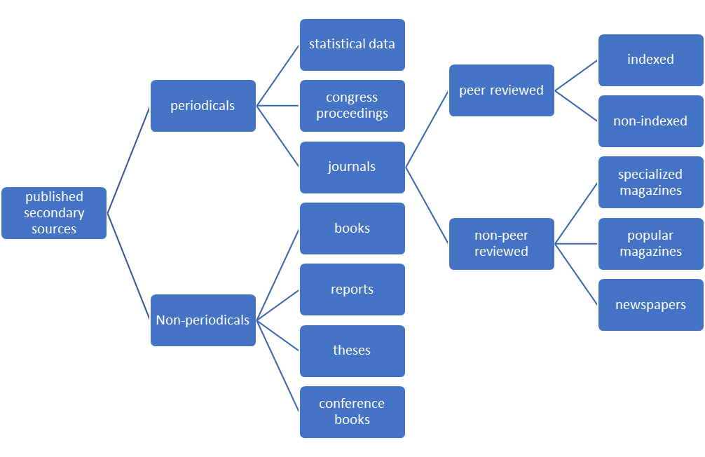
Using these resources helped identify the following information.

- Conclusion should discuss limitations and future directions as well. Point out several future directions.
Thank you for this comment. I included the following information to the conclusion.
Limitations during the research were the use of secondary resources. Using secondary sources for the manuscript were a limitation because the information could be faulty and it was not gathered first-hand. The sample in the research was small, limiting the scope of the research. These results could be bias. Lastly, the paper addressed system error estimation in software development and fails to address error estimation in other industrial and business errors.
Future directions are as follows.
In the future, optimized data mining systems can be improved by the use of different platforms, and particularly by improving data mining using PSO algorithms. It is necessary to develop algorithms that can identify faults in advance, which will minimize costs and promote the quality of developed software systems. Future optimized data mining systems will improve the relationship between quality metrics and the potential defective modules, which will lead to improved performances, productivity, and lower operation costs.
Responses to Reviewer #2
- Please better define aims in the abstract.
I appreciate your feedback on the abstract. The aims of the research were defined as follows.
The aim of the paper was to show how static model of data mining is used to extract defects and the PSO algorithm. Another aim of the research was to develop an optimized software flaw prophecy system on data mining techniques namely Association Rule mining, Decision Tree, Naive Bayes and Classification integrated with Particle Swarm Optimization technique.
- Please move Figure 1 from introduction section in other place in the paper.
This comment was highly appreciated.
Figure 1 was moved from the introduction to the literature review section, related work.
- Write last paragraph in introduction with short structure of the paper.
The last part of the paper was structured as per the comment. The edited paragraph is as shown below.
The results of the paper show that the proposed software flaw prediction system is deliberated through Data Mining techniques with Particle Swarm Optimization algorithm. This system can be used to identify the relationships between the quality metrics and the potential defective modules. These systems are beneficial because they offer a perfect prediction of the defective modules.
- Cite the following paper
In addition to the sources used in the manuscript, the following citation was used.
Puška, A., StojanoviÄ‡, I., MaksimoviÄ‡, A., & OsmanoviÄ‡, N. (2020). Evaluation software of project management used measurement of alternatives and ranking according to compromise solution (MARCOS) method. Operational Research in Engineering Sciences: Theory and Applications, 3(1), 89-102.
- Tables 1 and 2 isn't in margin.
Tables 1 and 2 were aligned with the margin as shown in the manuscript.
- Conclusion is too short. Please summarize your work in this section with emphasis on contribution.
The conclusion was extended to include the following information.
The aim of the paper was to show how static model of data mining is used to extract defects and the PSO algorithm. Another aim of the research was to develop an optimized software flaw prophecy system on data mining techniques namely Association Rule mining, Decision Tree, Naive Bayes and Classification integrated with Particle Swarm Optimization technique.
The current research contributes to the existing knowledge on identifying the contributions of Particle Swarm Optimization (PSO) in identification of errors during software development. Software project managers have relied on different techniques to identify faults in the process. Identification of these faults has enabled software project managers make optimal use of people, costs, and time to improve quality assurance. Also, these techniques have been used to plan production process improvements. The research will provide newer techniques to software developers and managers, which, in turn will enable them develop quality software systems. This research will add to the current knowledge on how the process of software development can be optimized, ensuring all stages of the production process are in check. Ensuring that the implemented policies and standards are adhered to will improve the quality of developed systems.
The proposed software flaw prediction system is deliberated through Data Mining techniques with Particle Swarm Optimization algorithm has been verified and compared the results. This proposed system is very useful to identify the relationships between the quality metrics and the potential defective modules. The optimized data mining systems have pragmatic perfect prediction of these defective modules. This optimized software flaw prediction system is better than normal software error prediction methods.
Limitations during the research were the use of secondary resources. Using secondary sources for the manuscript were a limitation because the information could be faulty and it was not gathered first-hand. The sample in the research was small, limiting the scope of the research. These results could be bias. Lastly, the paper addressed system error estimation in software development and fails to address error estimation in other industrial and business errors.
In the future, optimized data mining systems can be improved by the use of different platforms, and particularly by improving data mining using PSO algorithms. It is necessary to develop algorithms that can identify faults in advance, which will minimize costs and promote the quality of developed software systems. Future optimized data mining systems will improve the relationship between quality metrics and the potential defective modules, which will lead to improved performances, productivity, and lower operation costs.
Responses to Reviewer #3
- Highlight the novelty of the research.
The novelty of the research was to highlight and address the research gap and contribution of novel technologies; that is optimized data mining techniques and determining the relationship between the quality metrics and the potential defective modules. By evaluating past research, the current research found out that optimized data mining systems have pragmatic perfect prediction of these defective modules.
- Address typing errors.
All typing errors in the manuscript were corrected.
- Section 3 should be research method.
The paper was formatted to have the research method in section 3.
- Keywords:
The keywords were changed as follows.
Association Rule Mining; Data Mining (DM); Decision Tree, Naive Bayes, Particle Swarm Optimization (PSO), Software Flaws, Software Quality.
- Conclusion
More information was added to the conclusion to include summary of research findings, limitations, recommendations, and future directives.
- Modification of the abstract
More information was added to the abstract to include research aims, findings, and future directions.
The aim of the paper was to show how static model of data mining is used to extract defects and the PSO algorithm. Another aim of the research was to develop an optimized software flaw prophecy system on data mining techniques namely Association Rule mining, Decision Tree, Naive Bayes and Classification integrated with Particle Swarm Optimization technique.
The proposed software flaw prediction system is deliberated through Data Mining techniques with Particle Swarm Optimization algorithm has been verified and compared the results. This proposed system is very useful to identify the relationships between the quality metrics and the potential defective modules. The optimized data mining systems have pragmatic perfect prediction of these defective modules.
In the future, optimized data mining systems can be improved by the use of different platforms, and particularly by improving data mining using PSO algorithms. It is necessary to develop algorithms that can identify faults in advance, which will minimize costs and promote the quality of developed software systems. Future optimized data mining systems will improve the relationship between quality metrics and the potential defective modules, which will lead to improved performances, productivity, and lower operation costs.

